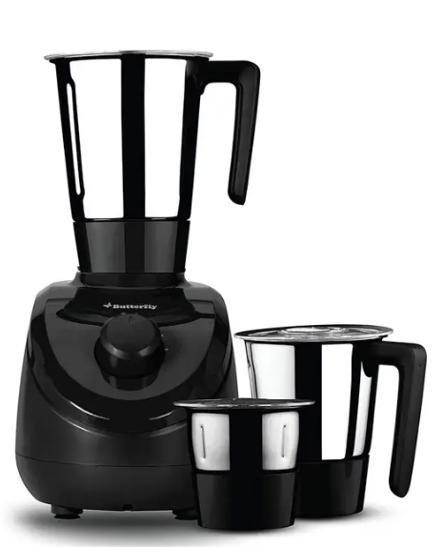

LG Mixer Grinder
Rs.25,184
An LG mixer grinder is a multi-functional kitchen appliance used for grinding spices, blending ingredients, and preparing pastes, juices, and batters. It is designed for fast, efficient, and everyday cooking tasks with a powerful motor and durable components.

Specifications
- Model: MG200
- Type: Mixer Grinder
- Power: ~850W – 1000W
- Voltage: 220–240V

Key Features
- Powerful Motor
- Durable Components
- 3-Speed Control + Pulse
- Multi-functional Jars

